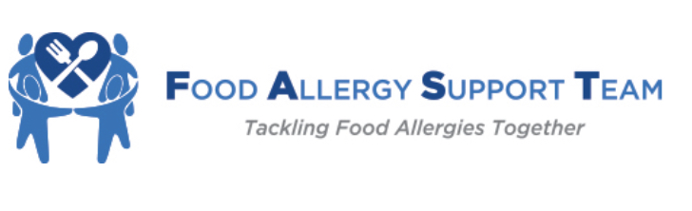
7th Annual Meeting Registration
Dallas, Texas: June 21-22, 2024
Hyatt Regency, Dallas-Ft. Worth Airport

Please complete and email this form to pfdetjen@gmail.com and submit $495 per attendee via:

- FAST Annual Meeting 2024

- Zelle via your bank to: pfdetjen@gmail.com

- Or check made out to Food Allergy Support Team - and mail with this form to:
Kenilworth Medical Associates - FAST
- Green Bay Road
Kenilworth, IL 60043

Practice name: ________________________________________________________________________________

City/State: _____________________________________________________________________________________

- Name:_______________________________________________________ (MD/DO PA/NP* RN/RT/MA)

Email_________________________________________________________________________________________

- Name:_______________________________________________________ (MD/DO PA/NP* RN/RT/MA)

Email_________________________________________________________________________________________

- Name:_______________________________________________________ (MD/DO PA/NP* RN/RT/MA)

Email_________________________________________________________________________________________

*Mid-level providers should be accompanied by their supervising Allergist/Immunologist or that PA/NP should have attended a past FAST meeting.
**Meeting registration includes Friday lunch, dinner reception, break snacks, and Saturday breakfast and lunch. No refunds after June 1st.
**Friday Beginner sessions 9am-12pm and Joint sessions 1pm-6pm, Saturday 7am-3pm.
A block of rooms for $139/night is being held at the Hyatt Regency Airport Hotel (not Grand Hyatt at same airport). Book your room online by clicking Food Allergy Support Team (hyatt.com) or by calling 888-591-1234 and mentioning the Food Allergy Support Team meeting. Book your room early before the discounted rooms are gone.

